Why country ratings are most important among the different types of credit rating

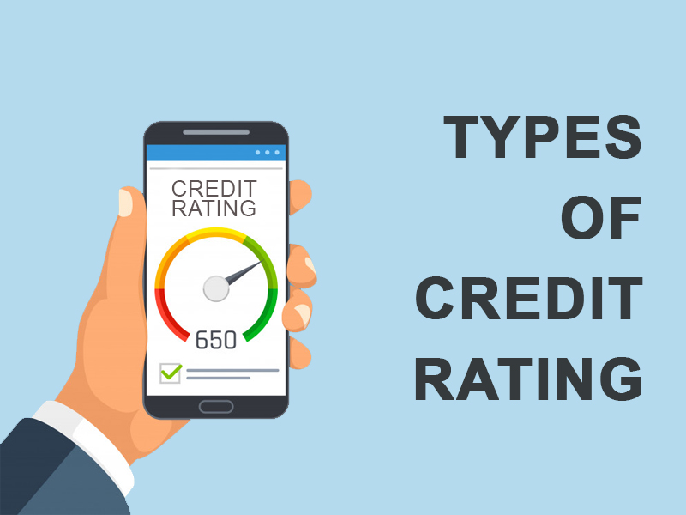

We have all heard about credit ratings. Apparently, we know that it is a financial assessment of businesses/ corporates, countries/ states, just like the monetary standing or [credit risk of individuals](https://scocre.com/) are assessed.

Technically said, ‘credit rating is a measure of solvency of an entity’. This term may be difficult to understand, and hence, it would be better understood if said that credit rating is based on detailed analysis of a given entity’s past financial performance of borrowing, lending and operating activities. The ratings are awarded by established credit rating agencies.

Moving ahead we would like to tell you that there are different [types of credit rating](https://scocre.com/blogs/types-of-credit-rating.php) to analyse the repaying capacity of an entity- be it a company or a country. Debenture/bond, equity/ shares, commercial paper, fixed deposit and borrower’s rating are some of the different categories of credit rating, but in today’s article, let’s concentrate on various factors of country credit rating.

But before that let us check out how these credit rating agencies grade respective entities.

Credit ratings is a tool that is a combination of alphabets and symbols such as ‘AAA’ and ‘+’. The ratings range from A++ to D. If the ratings are on a higher side, i.e., A++, then the lenders consider it as a positive sign and are comfortable lending a big amount to the business entities or countries. On the other hand, ratings that rank among the lower range such as C or D, then such borrowing entities are considered as high-risk borrowers and have to incur heavy interest rates while repaying the dues.

With respect to a country’s credit rating, the agency evaluates a nation’s economic and political environment and then assigns it with grades accordingly.

**What is** [**country credit rating**](https://en.wikipedia.org/wiki/List_of_countries_by_credit_rating)**?**

Also known as a sovereign credit rating, it is an independent assessment of the credit worthiness of a nation or to know if investing in a particular country is going to be fruitful. It provides an insight into the borrowing country’s repaying capacity.

Having a good sovereign credit rating holds vital importance for developing nations who wish to access the international bond or debt markets. In addition to this, the investors use the designated grades to assess the riskiness of the bonds issued by specific nations. Hence, the good or bad ratings encourage or discourage the investors from investing in the bonds issued by a nation.

There are several factors such as a country’s debt service ratio, its boost in domestic money supply, its import ratio, variance of its export revenue and so on that play a role in determining the riskiness of a country. On the other hand, the country in which the investment is being made is used by the respective government to boost its infrastructure and other resources to provide its people with better facilities.

**Conclusion**

So, you see, a country’s credit rating plays an important factor in determining whether a government may or may not be able to repay its debt obligations in the future.